Issue Management Approach
A CORE SPICE Asset
Table of Contents
1 Purpose 2
2 Scope 2
3 Assumptions and Constraints 2
4 Policy and Objectives 3
5 Roles, Responsibilities, and Assignments 3
6 Stakeholders 5
6.1 Internal Stakeholders 5
6.2 External Stakeholders 5
7 Meeting & Reporting Structure 6
7.1 Meetings 6
7.2 Safety/Cybersecurity Escalation Meetings (ad hoc) 6
7.3 Reporting 6
8 Project Input 7
9 Outcomes 7
9.1 Issue Management Process 7
9.2 Traceability and Consistency 7
9.3 Project Management Integration 8
9.4 Quality Assurance 8
9.5 Functional Safety and Cybersecurity Compliance 9
9.6 Additional Project-Specific Outcomes (Door Lock, JIRA) 9
10 Lifecycle Management 9
10.1 Defect Lifecycle 9
10.2 Change Request Lifecycle 10
10.3 Project Task Lifecycle 12
11 Planning 12
12 Resources 13
13 Infrastructure Management 13
14 Risk Reduction 13
15 Related Approaches 13
16 Annexes 14
16.1 Acronyms and Glossary 14
16.2 References 14

Purpose
The Issue Management Approach provides a structured process for identifying, classifying, analyzing, resolving, tracking, and communicating issues throughout the project lifecycle. It ensures the timely resolution of problems affecting system, software, and hardware development, with a focus on functional safety and cybersecurity risks. This Approach supports compliance with ASPICE, ISO 26262, and ISO 21434 by minimizing project risks and maintaining a quality culture.

Scope
This Approach applies to all activities related to identifying and resolving issues within the Door Lock Control ECU development, covering system, software, hardware, and V&V activities.
Covered scope:
- Issue types:
  - Defects (system, software, hardware, integration, validation)
  - Change Requests (requirements changes, design updates, interface modifications)
  - Project Tasks (planned work items tracked for project execution)
- Lifecycle phases:
- Concept → Requirements → Architecture → Design → Implementation → VVT → Release
- Teams involved:
- System, Software, Hardware, Integration, VVT, Functional Safety, Cybersecurity, Configuration, CI, Supplier Management.

Assumptions and Constraints
Assumptions
- All team members have access to the Issue Management System (JIRA).
- All issues affecting safety, security, or delivery performance must be reported immediately.
- Automated traceability tooling (sync to DNG, Git, CI pipelines) is available.
Constraints
- Access rights must follow “need-to-know” for safety- and security-relevant issues.
- JIRA workflows are standardized for the entire project and cannot be modified by individual teams.
- Tool licenses may restrict advanced reporting dashboards.

Policy and Objectives
Policy
- Every issue must be recorded, classified, and managed in JIRA.
- High-severity issues (safety, security, regressions, supplier blockers) require immediate escalation to the Project Lead.
- No issue may be closed without verification by the responsible VVT role (or equivalent).
Objectives
- Ensure timely identification and resolution of all issues.
- Reduce recurrence through root-cause analysis and structured follow-up.
- Maintain complete traceability across requirements, design, code, tests, and issues.
- Provide consistent reporting to project management and stakeholders.
- Support ASIL D and cybersecurity objectives through structured handling of critical issues.

Roles, Responsibilities, and Assignments
The following roles apply:
Role | Responsibility | Assignment | Remarks
Project Lead | Owns overall issue flow, prioritizes critical issues, resolves cross-team conflicts, and escalates externally as needed. | TBD | Leading role.
TCC | Monitors IMS compliance, supports quality topics, performs audits, and process coaching. | TBD | Ensures consistency with CORE SPICE methods.
Technical Lead | Performs root-cause analysis of technical issues and defines resolution strategies. | TBD | Provides expert-level evaluation.
VVT Lead | Verifies resolution through tests, confirms completeness before closure. | TBD | Must approve closure of defects.
FuSa Engineer | Flags and tracks safety-related issues; ensures correct ASIL handling. | TBD | Safety-critical relevance.
Cybersecurity Engineer | Flags and tracks CS issues, ensures secure mitigation. | TBD | CS-critical relevance.
Configuration Lead | Ensures correct baselines and traceability links; checks completeness before releases. | TBD | Supports audits.
CI Lead | Detects CI build failures and logs issues for pipeline and build regressions. | TBD | Automates detection.
Supplier Lead | Manages supplier-raised issues and external dependencies. | TBD | Coordinates supplier workflows.
NEW ROLE: Issue Flow Manager (IFM) | Operates daily issue flow: triage, assignment, SLA monitoring, workflow correctness, dashboard curation; reports directly to Project Lead. | TBD | Not part of CORE SPICE catalog, created specifically for this Approach.
Project Tools Engineer | Maintains automation, JIRA integrations, dashboard scripts. | TBD | Supports the IFM and TCC.
The Issue Flow Manager (IFM) is the central operational role responsible for ensuring fast processing and ticket consistency across all teams. It acts as the “traffic controller” of the IMS.

Stakeholders

Internal Stakeholders
- Project Lead
- Technical Lead
- TCC
- VVT Lead
- FuSa Engineer
- Cybersecurity Engineer
- Configuration Lead
- CI Lead
- Integration Lead
- Supplier Lead
- All developers (system, software, hardware)

External Stakeholders
- Customer representatives (OEM reviewers)
- Suppliers providing modules, code, or tests
- External auditors (FuSa, cybersecurity, quality)

Meeting & Reporting Structure

Meetings
- Daily Issue Standup (15 minutes)
Led by IFM; covers new issues, blockers, critical changes.
- Weekly Issue Review (1 hour)
PL + TL + VVT + FuSa + Cybersecurity + TCC.
Focus: aging issues, defects trends, upcoming milestones, risk issues.

Safety/Cybersecurity Escalation Meetings (ad hoc)
- Triggered by ASIL D or CS vulnerabilities.
- Supplier Issue Review (bi-weekly)
- Supplier Lead + Project Lead + Technical Lead.

Reporting
- Weekly Issue Status Report (automated dashboards)
Open issues, trends, SLA compliance, safety/security focus.

- Release Readiness Report
Must show:
  - No open ASIL-relevant issues
  - Security vulnerabilities addressed or accepted
  - No critical defects in “In Progress” or “Resolved” state
- Management Summary
Provided by Project Lead based on IFM data.

Project Input
- Issue reports from development and test teams
- CI pipeline log failures
- Supplier issue reports
- Safety incident logs
- Cybersecurity vulnerability scans
- Requirements and design baselines
- Test results, regression reports
- Project schedule and release milestones

Outcomes

Issue Management Process
- Systematic issue handling
Issues are identified, documented, and classified in the Issue Management System (JIRA) as defects, change requests, or project tasks. Significant issues receive root cause analysis. All issues are resolved and tracked to closure.
- Verified effectiveness of resolutions
The effectiveness of each resolution is verified before the issue is closed. For defects, this includes successful re-test in the relevant test level and confirmation that no unacceptable regressions have been introduced.
- Clean project closure
All issues are resolved before project closure. Any remaining issues are explicitly documented with their risk assessment, justification, and responsible owner (e.g., transferred to maintenance or OEM systems).

Traceability and Consistency
- Bidirectional traceability
Bidirectional traceability is established and maintained between issues (defects, change requests, tasks) and affected work products (requirements, design elements, code, test cases, test results, and baselines). Traceability is implemented in JIRA and supporting tools (e.g., DOORS Next, Git, CI).

Project Management Integration
- Risk handling based on issues
Risks related to issues (including safety and cybersecurity relevance, schedule impact, and quality impact) are identified, analyzed, and mitigated. High-risk issues are escalated to the Project Lead and recorded in the project’s risk and action tracking.
- Project plan synchronization
Project plans and backlogs (roadmaps, milestone plans, sprint backlogs) are adjusted to incorporate effort for issue analysis, resolution, and verification. This includes explicit planning of work for safety- and cybersecurity-related issues.
- Monitoring and reporting
Progress on issue resolution and trends is monitored using JIRA dashboards and reports. Status, lead times, aging of issues, and critical trends are reported regularly in project status meetings and release readiness reviews.
- Training on issue management
Team members receive initial and, if needed, refresher training on the JIRA workflows, issue types (defects, change requests, tasks), fields (priority, severity, safety/security flags), and the life cycle definitions used in this project.
- Continuous improvement of issue handling
Lessons learned from issue handling (including recurring root causes, process gaps, and tool limitations) are collected and evaluated. The Issue Management Approach, JIRA workflows, and supporting guidelines are updated accordingly.

Quality Assurance
- Verification of conformance
The conformance of work products and processes with the defined Issue Management Approach is verified. Non-conformances (e.g., missing links, incorrect states, skipped verification) are recorded, analyzed, and resolved.
- Issue audits and peer reviews
Issue audits and peer reviews are conducted to check the quality and completeness of tickets (e.g., problem description, root cause, implemented fix, trace links, test evidence) and to confirm adherence to the defined workflows.

Functional Safety and Cybersecurity Compliance
- Functional safety issues (ASIL D)
Safety-critical issues relevant to ASIL D are explicitly marked in the IMS and prioritized. Their handling and closure follow the functional safety process, including impact analysis on safety requirements, safety mechanisms, and the safety case.
- Cybersecurity issues
Cybersecurity-related issues (e.g., vulnerabilities, weaknesses, penetration test findings) are identified, flagged in JIRA, tracked, and resolved following the cybersecurity process, including impact on cybersecurity goals and the cybersecurity case.

Additional Project-Specific Outcomes (Door Lock, JIRA)
- Lifecycle coverage per issue type
For each issue type (defect, change request, project task), a defined lifecycle (states and transitions) is implemented in JIRA and applied consistently. No issue is left in ambiguous or obsolete states before release or project closure.
- Evidence for assessments and audits
The configured JIRA projects, dashboards, and trace links provide sufficient and consistent evidence for internal and external assessments and audits, including those focused on functional safety, cybersecurity, and process capability.

Lifecycle Management
The IMS workflow is implemented in JIRA. Three lifecycle models exist: Defect, Change Request, Project Task.

Defect Lifecycle
State | Transitions | Meaning
Open | → Triage | Defect created and awaiting IFM review.
Triage | → In Progress, → Needs More Info, → Rejected | IFM validates severity, assigns owner.
In Progress | → Resolved, → Blocked | Owner is fixing the defect.
Blocked | → In Progress | External dependency prevents progress.
Resolved | → Verification, → In Progress | Fix implemented, awaiting VVT verification.
Verification | → Closed, → In Progress | VVT executes tests.
Closed | – | Verified and completed.
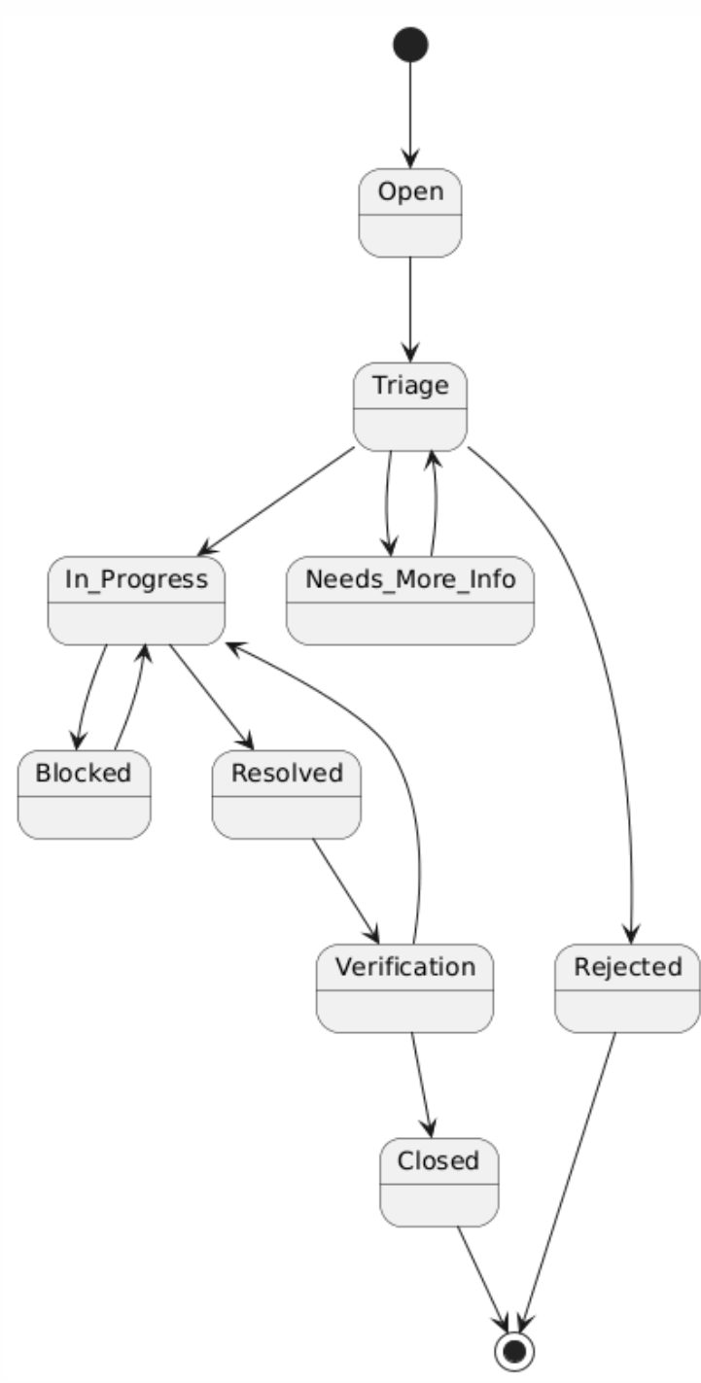
Figure 1 Defect Workflow
Special rules:
- Defects with FuSa relevance require FuSa Engineer review before closure.
- Defects with Security relevance require Cybersecurity review.

Change Request Lifecycle
State | Transitions | Meaning
Open | → Impact Analysis | CR created and awaiting impact analysis.
Impact Analysis | → Approval Pending, → Rejected | Technical, safety, cybersecurity, and project impact are analyzed.
Approval Pending | → In Progress, → Rejected | Project Lead (and customer if required) approves or rejects CR implementation.
In Progress | → Resolved, → Blocked | Implementation of the approved change is ongoing.
Blocked | → In Progress | External dependency or prerequisite prevents progress.
Resolved | → Verification, → In Progress | Change implemented and integrated; awaiting verification.
Verification | → Closed, → In Progress | Verification (tests, reviews, baselines) is performed; if failed, returns to In Progress.
Closed | – | Verified and completed.
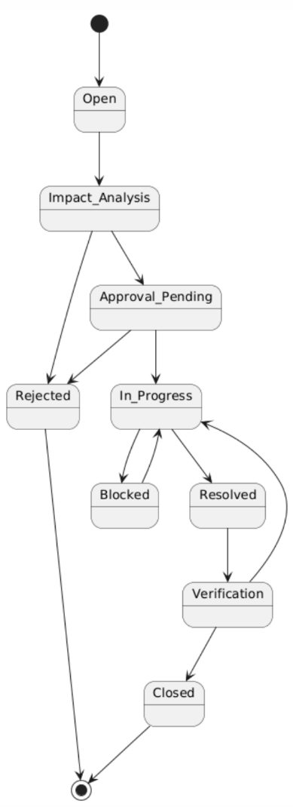
Figure 2 Change Requests Workflow
CRs must maintain bidirectional traceability to requirements and design artifacts.

Project Task Lifecycle
State | Transitions | Meaning
Planned | → In Progress, → Cancelled | Task defined in backlog; not yet started.
In Progress | → Review, → Done, → Blocked | Task owner is actively working on it.
Blocked | → In Progress, → Cancelled | Task progress is prevented by an external dependency.
Review | → Done, → In Progress | Optional peer or stakeholder review before completion.
Done | – | Task completed and accepted.
Cancelled | – | Task is discontinued and will not be completed.
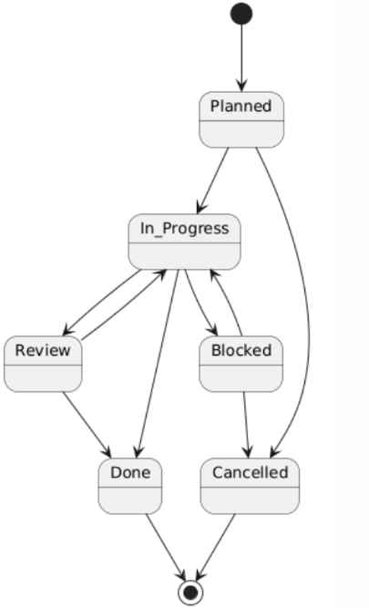
Figure 3 Tasks Workflow
Tasks may not require verification unless linked to a safety/security deliverable.

Planning
- IMS setup completed during project kickoff.
- Issue workflows verified before first baseline (SYS.2).
- Regular reviews aligned with milestone gates (CM baselines, SW releases).
- Final audit before release to customer.

Resources
- Primary IMS: Atlassian JIRA (project-specific workflows, fields, dashboards)
- Supporting Tools:
  - Git / Bitbucket (commit linking)
  - Jenkins / GitLab CI pipelines
  - DOORS Next Generation (requirements tracing)
  - Static analysis tools (SAST) for automated defect detection
  - Cybersecurity scanners
- Root-cause-analysis templates (5-Why, Ishikawa, 8D)

Infrastructure Management
- JIRA server/cloud instance with project-specific schema.
- Access rights based on least privilege.
- Automated notifications for new issues.
- Secure remote access via VPN for all contributors.
- Backup and retention policies to prevent loss of project data.

Risk Reduction
- Early identification of safety/security-relevant issues through dedicated fields.
- Automated alerts when high-severity issues exceed SLA.
- Weekly audits by TCC and IFM.
- CI-based regression detection prevents silent defects.
- Backup and restore procedures ensure data integrity.

Related Approaches
- Project Approach
- Configuration Management Approach
- Change Request Management Approach
- Functional Safety Approach
- Cybersecurity Management Approach
- Traceability Approach
- VVT Approach

Annexes

Acronyms and Glossary
- IMS – Issue Management System
- IFM – Issue Flow Manager
- VVT – Verification, Validation & Testing
- CR – Change Request
- SLA – Service Level Agreement
- ASIL – Automotive Safety Integrity Level

References
See CORE SPICE License and related standards listed in the Release Repository. https://github.com/CORE-SPICE/CORE_SPICE_Releases

